**Sakila Qlik Sense SQL Server**

Question1:

List film categories with total rental amount, average rental amount, number of customers - tabular & sql query

select ca.name, sum(p.amount) as TotalRentalAmount, avg(p.amount) as AverageRentalAmount,

count(p.customer_id) as CustomerCount

from payment p

inner join rental r on p.rental_id=r.rental_id

inner join inventory i on i.inventory_id=r.inventory_id

inner join film f on i.film_id=f.film_id

inner join film_category fc on f.film_id=fc.film_id

inner join category ca on fc.category_id=ca.category_id

group by ca.name order by TotalRentalAmount desc

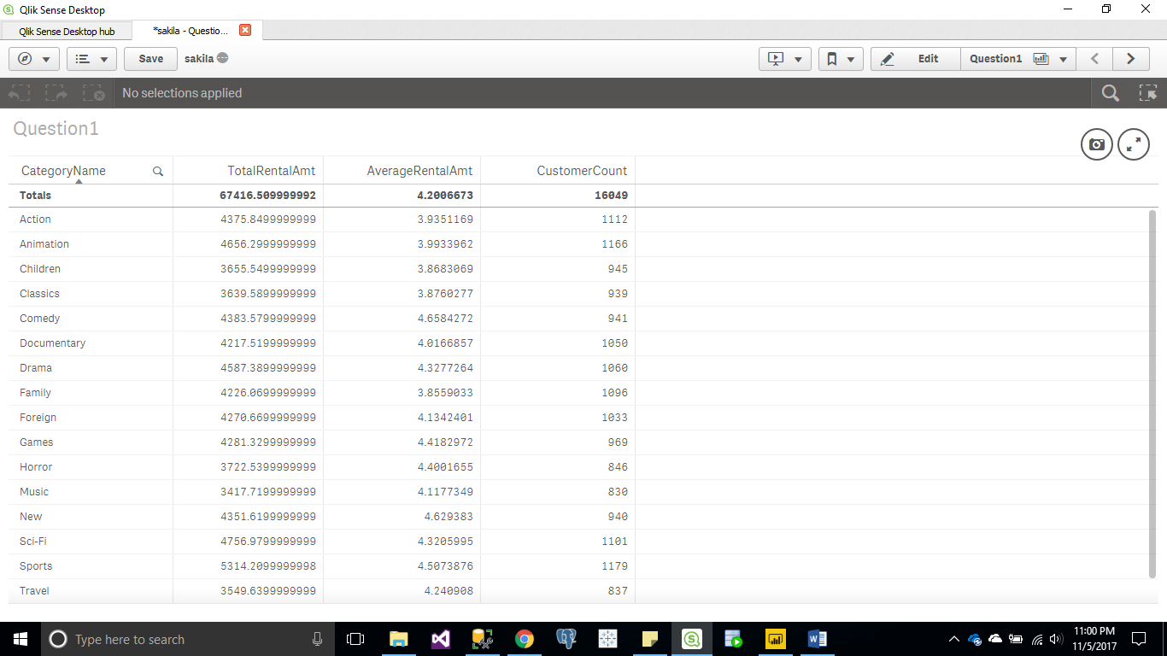

Question2:

List Customers (Last name, First Name) with rental amount, rental quantity, active status, country and city who are from Poland – tabular & sql query

select CONCAT(cu.last_name,',',cu.first_name) as customerName, sum(p.amount) as RentalAmount,

count(p.rental_id) as RentalQuantity, cu.active as activeStatus, co.country, ci.city

from payment p

inner join customer cu on p.customer_id=cu.customer_id

inner join address ad on cu.address_id=ad.address_id

inner join city ci on ad.city_id=ci.city_id

inner join Country co on ci.country_id=co.country_id

where co.country='Poland'

group by CONCAT(cu.last_name,',',cu.first_name), co.country, ci.city,cu.active

order by RentalAmount desc;

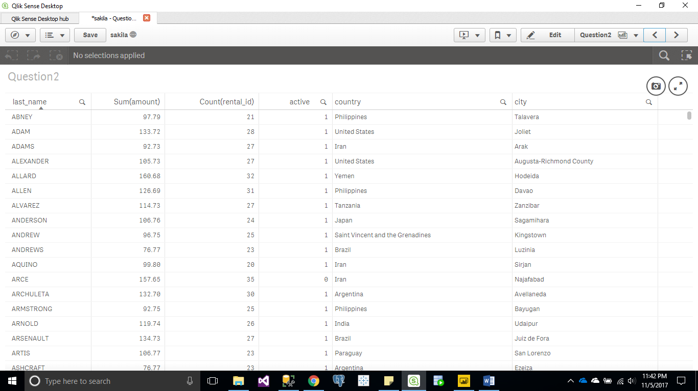

Question3:

List top 10 Films by rental amount (ranked) with replacement cost greater than $25 – bar chart & sql query

select Top 10 f.title, sum(p.amount) as RentalAmount,

Dense_Rank() over(order by sum(p.amount) desc) as FilmRank

from payment p

inner join rental r on p.rental_id=r.rental_id

inner join inventory i on i.inventory_id=r.inventory_id

inner join film f on i.film_id=f.film_id

inner join film_category fc on f.film_id=fc.film_id

where f.replacement_cost > 25

group by f.title;

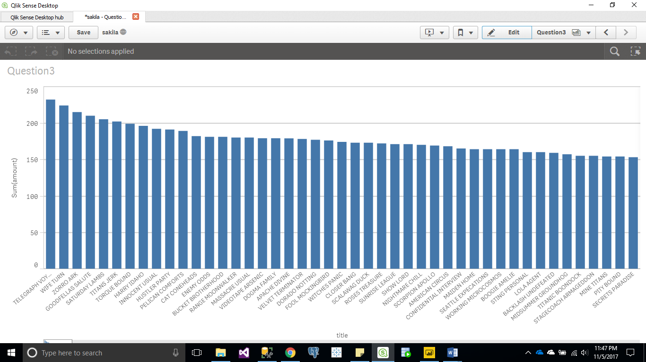

Question3:

Top 10 cities by rental amount – bar chart & sql query

select Top 10 ci.city, sum(p.amount) as RentalAmount

from payment p

inner join customer cu on p.customer_id=cu.customer_id

inner join address ad on cu.address_id=ad.address_id

inner join city ci on ad.city_id=ci.city_id

group by ci.city order by RentalAmount desc

